

NAME: JACOB JOSEPH ERISHLO
REGISTRATION NO: BIT/2025/69876
UNIT: MOBILE APPLICATION DEVELOPMENT
UNIT CODE: BIT4107
PROJECT TITLE: TWONKSACCO MOBILE BANKING APP

This mobile banking application is developed as an academic project for partial fulfillment of the requirements for the unit BIT4107: Mobile Application Development, to be submitted to the lecturer for assessment and academic grading
WEEK 1: INTRODUCTION TO MOBILE DEVELOPMENT

Learning Outcomes:
- Installed Android Studio, Flutter SDK, and Git
- Created first Flutter application
- Modified app title, colors, and font sizes
- Ran app on mobile phone
Installation of Android studio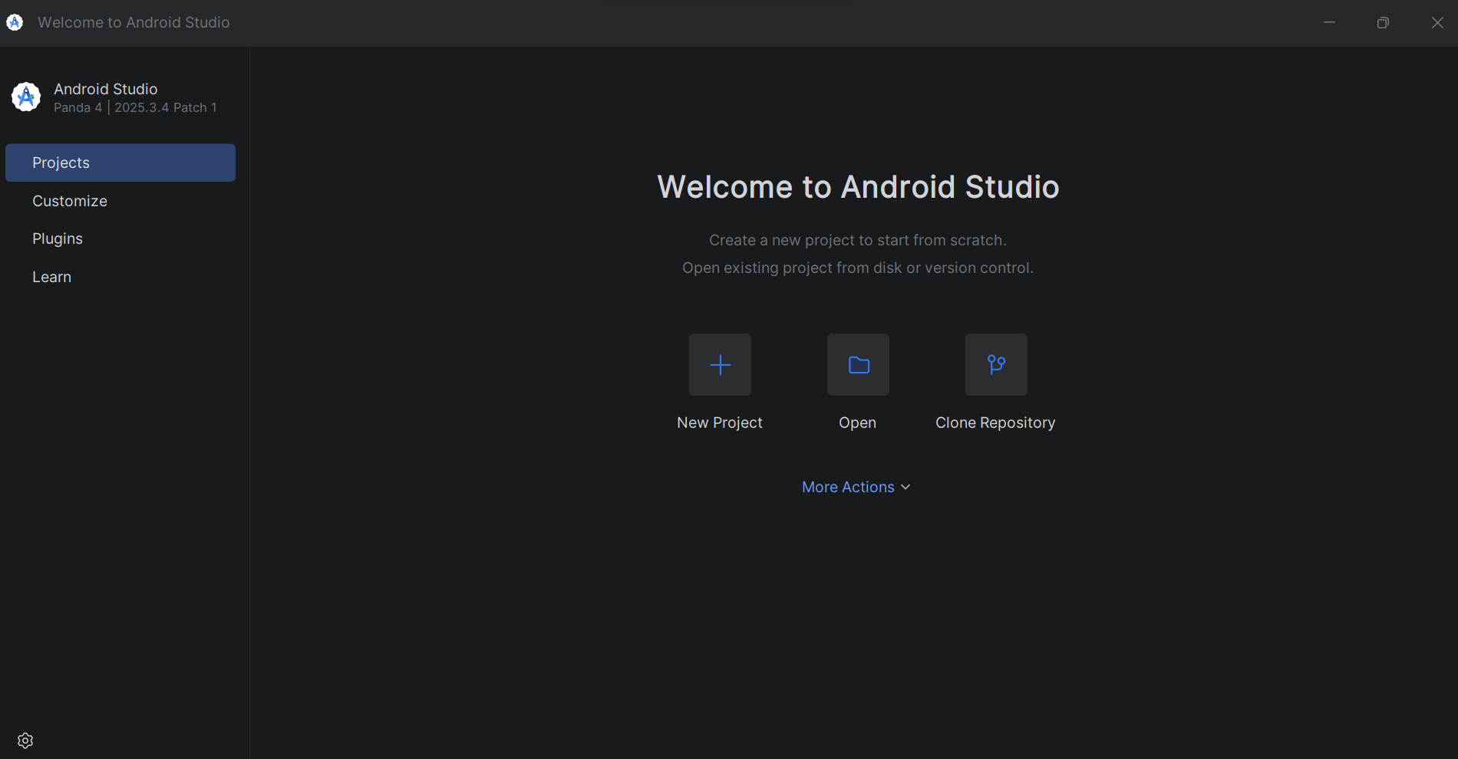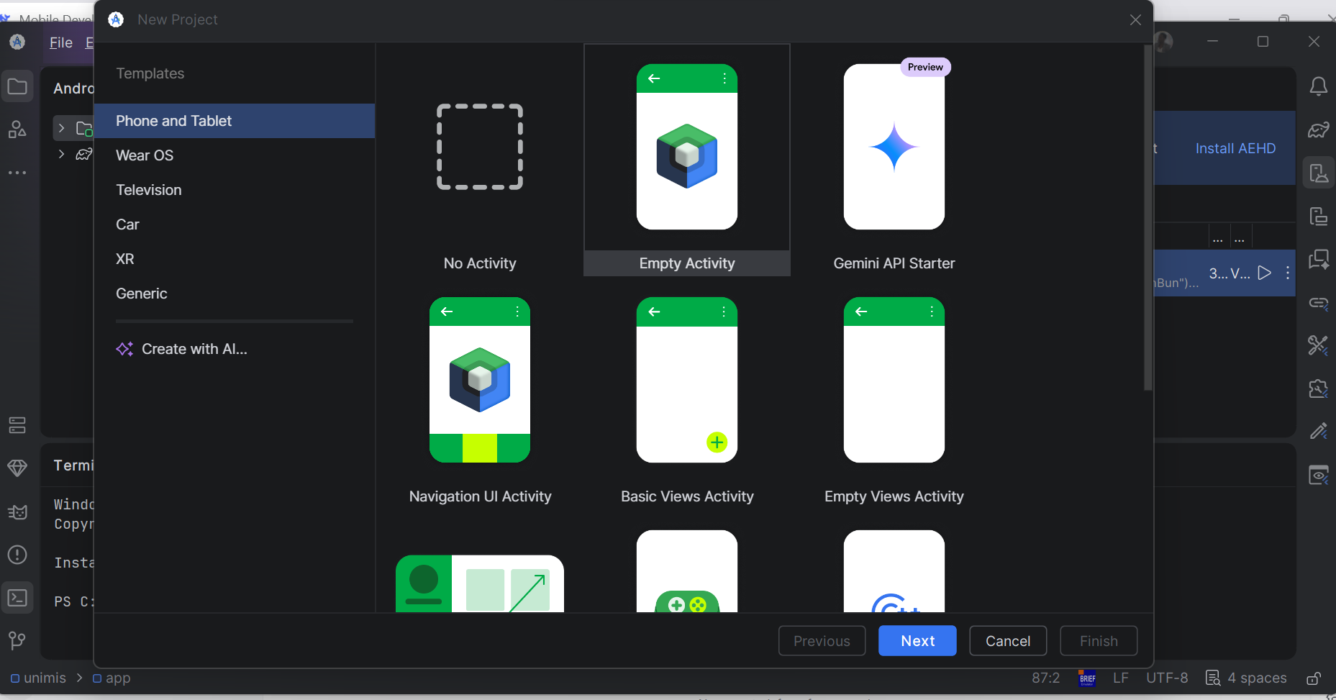

Installation and confirmation of JDK
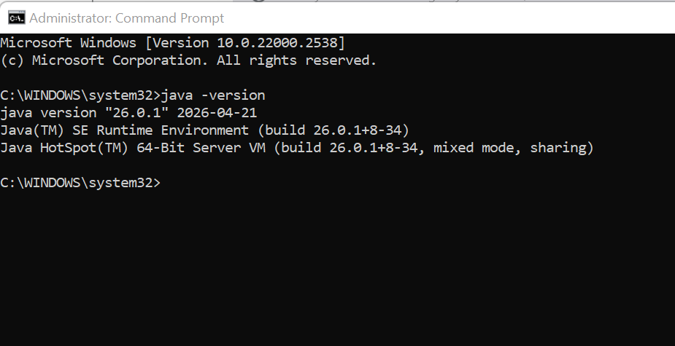

3. Git installation for windows
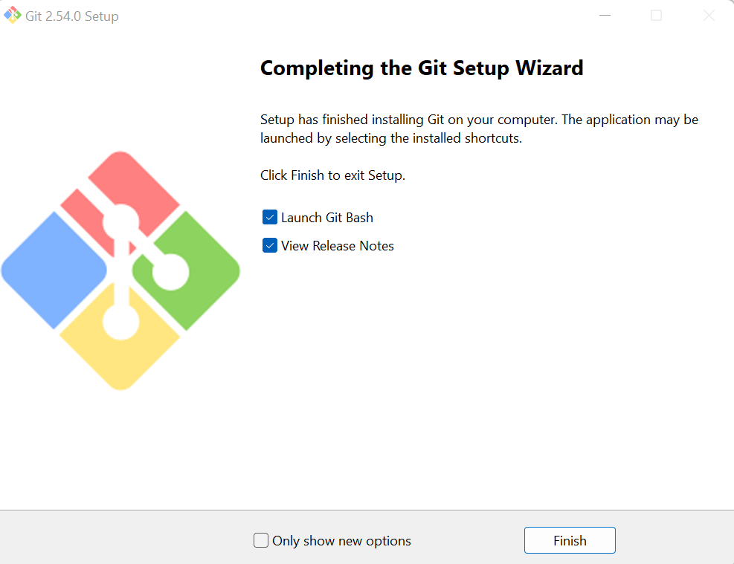

Installation and running of flutter
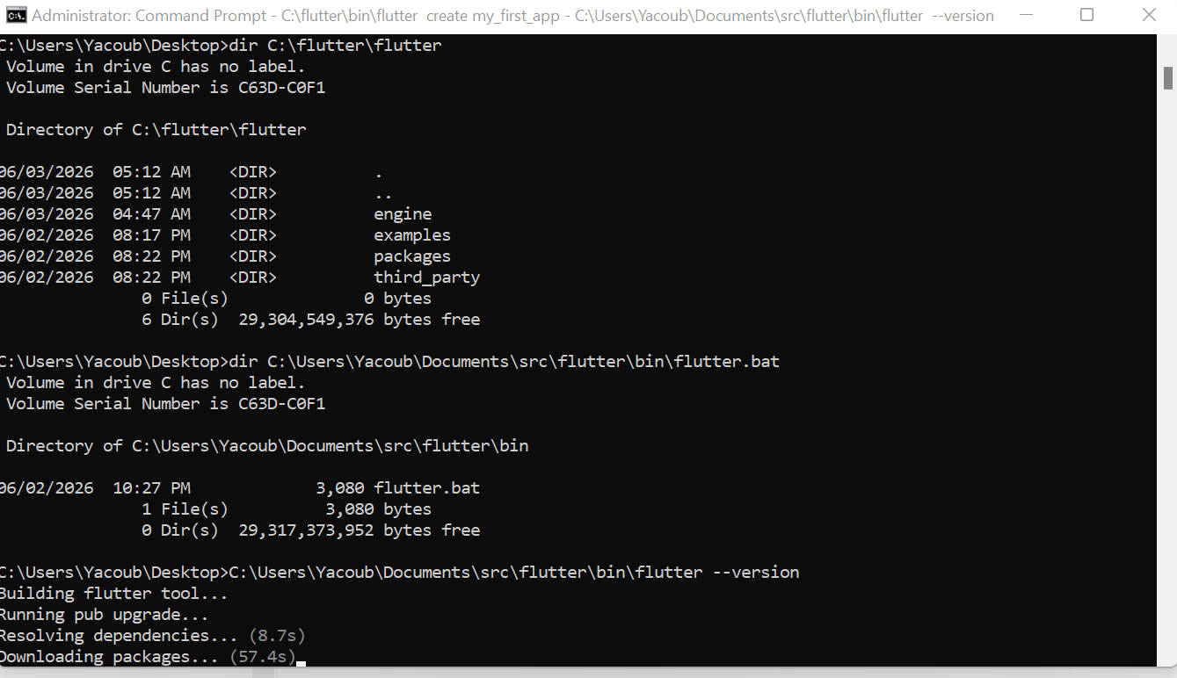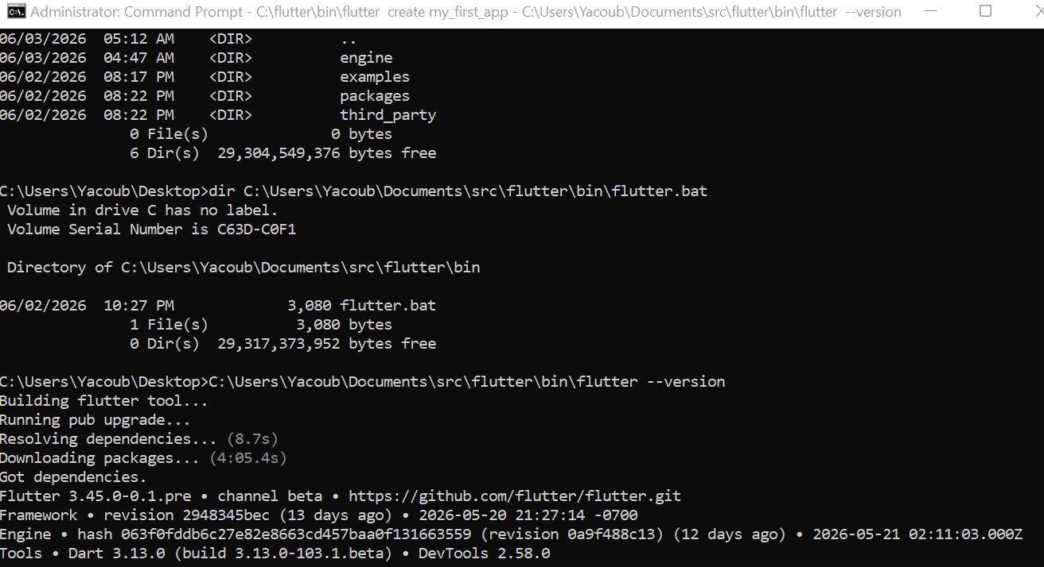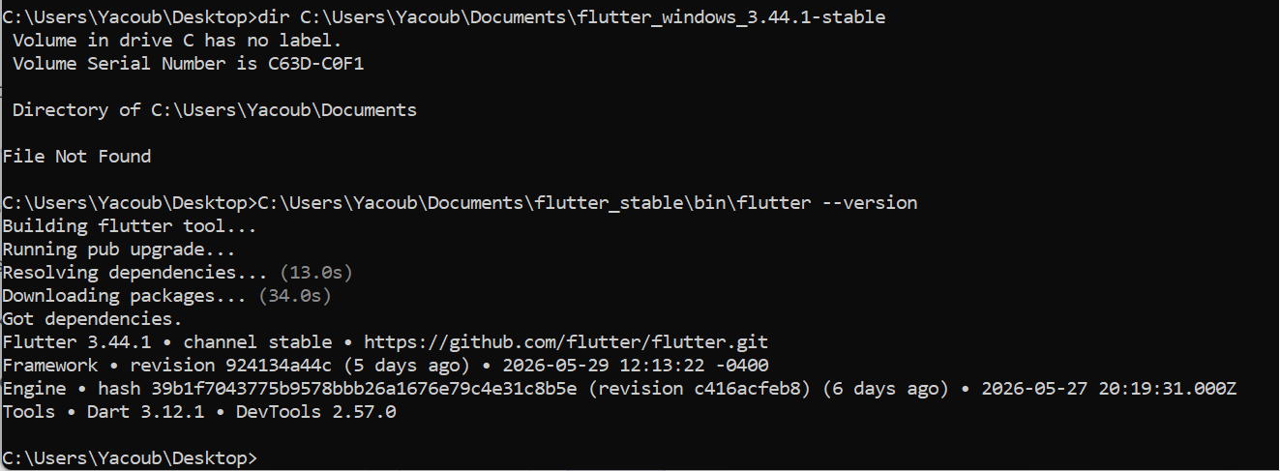
Created a student_manager_app:
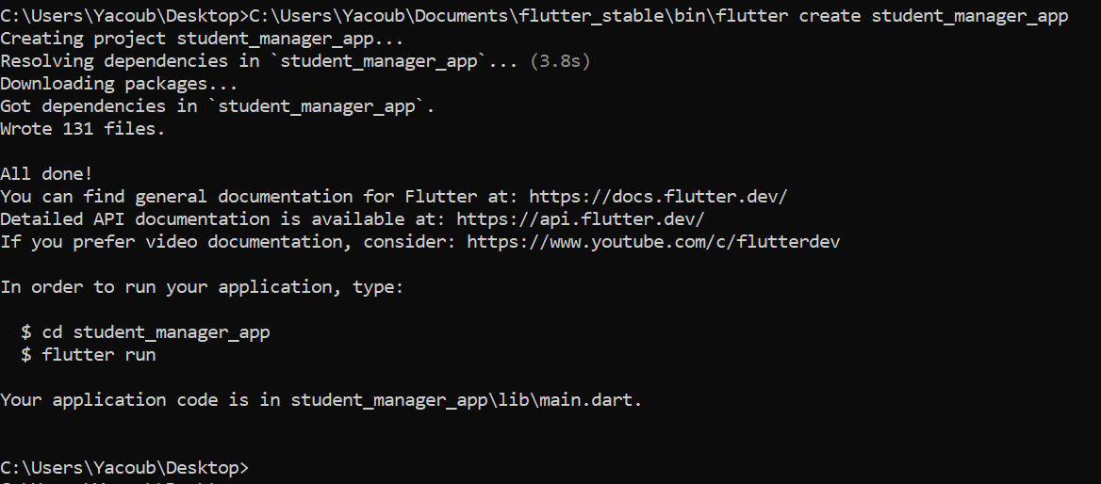
Installation of emulator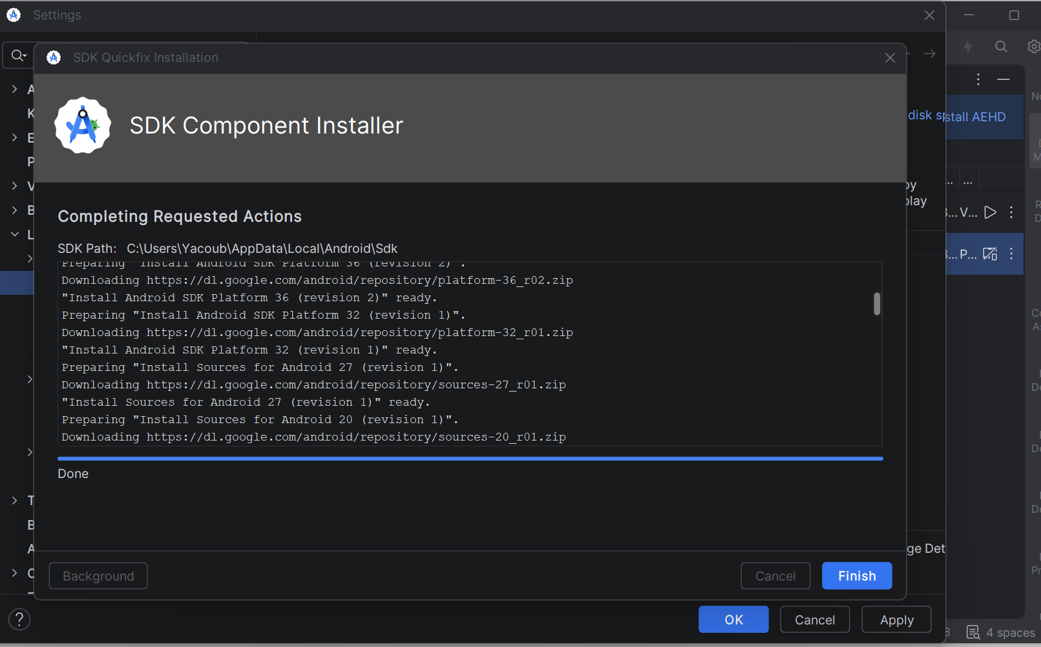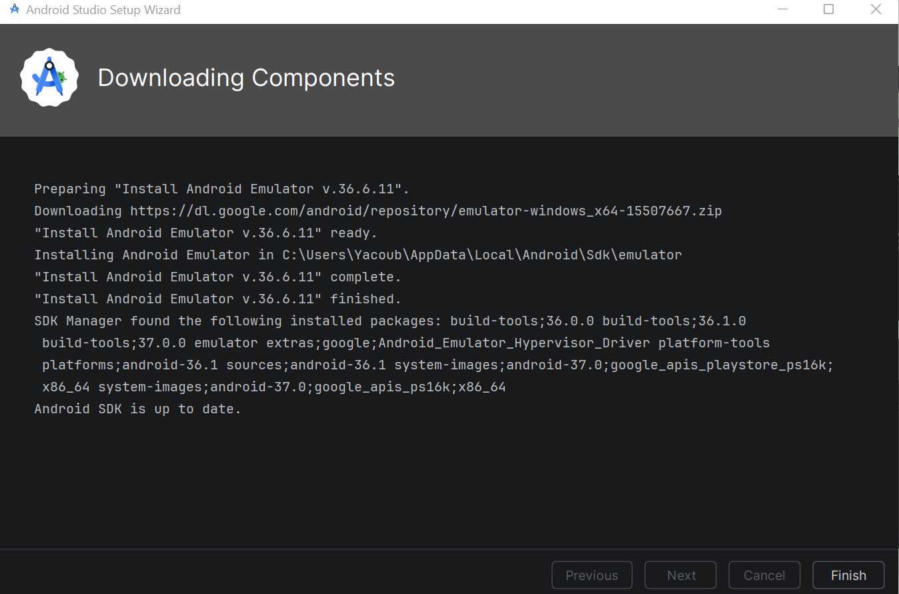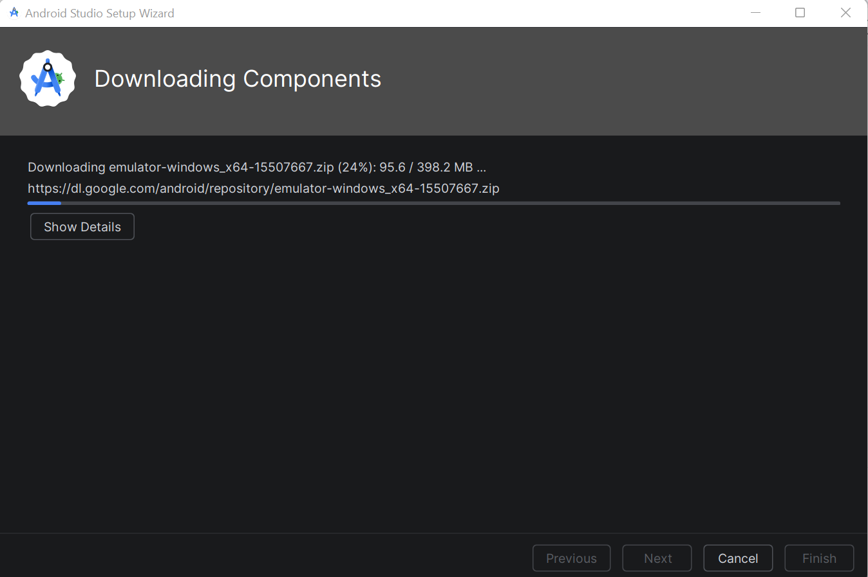

JDK Installed in the PC
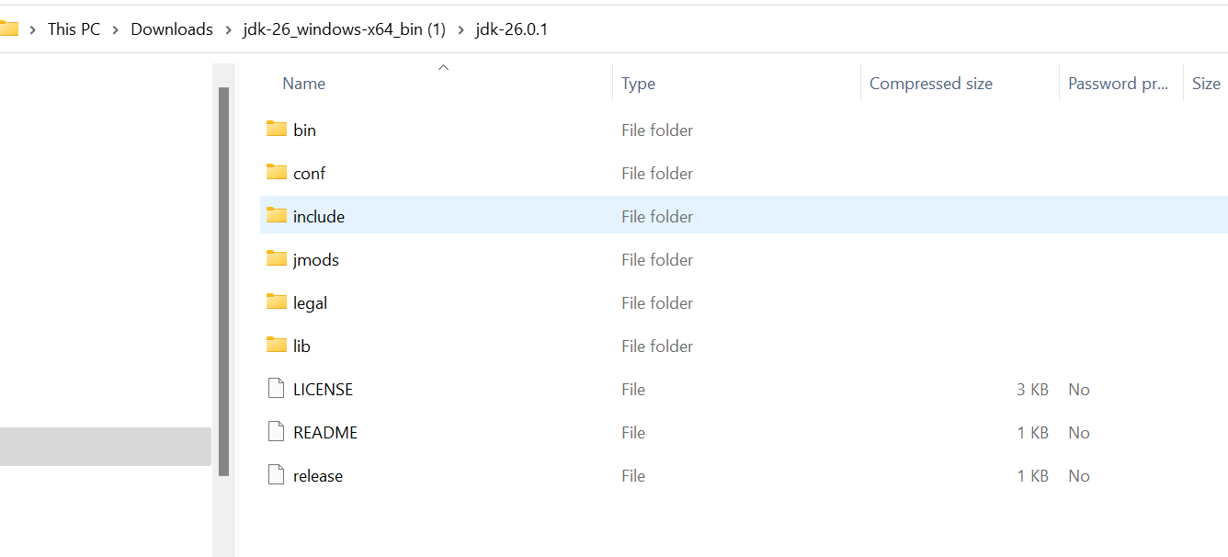
I

Installation of VS Code; 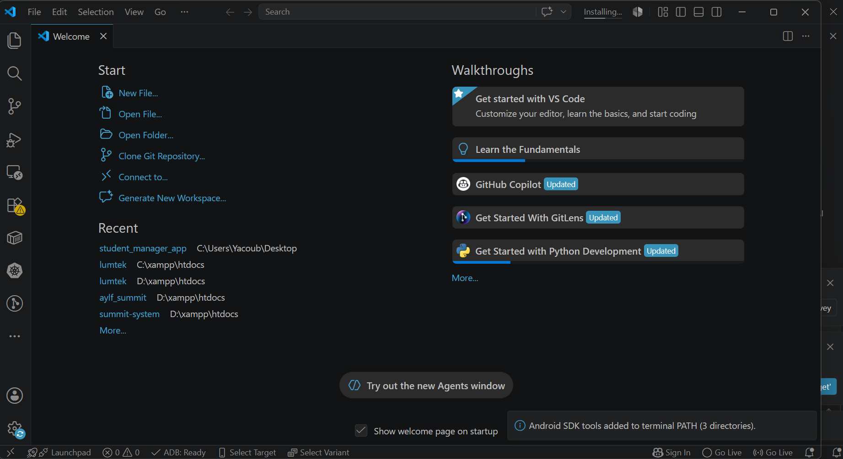

Flutter Installations; 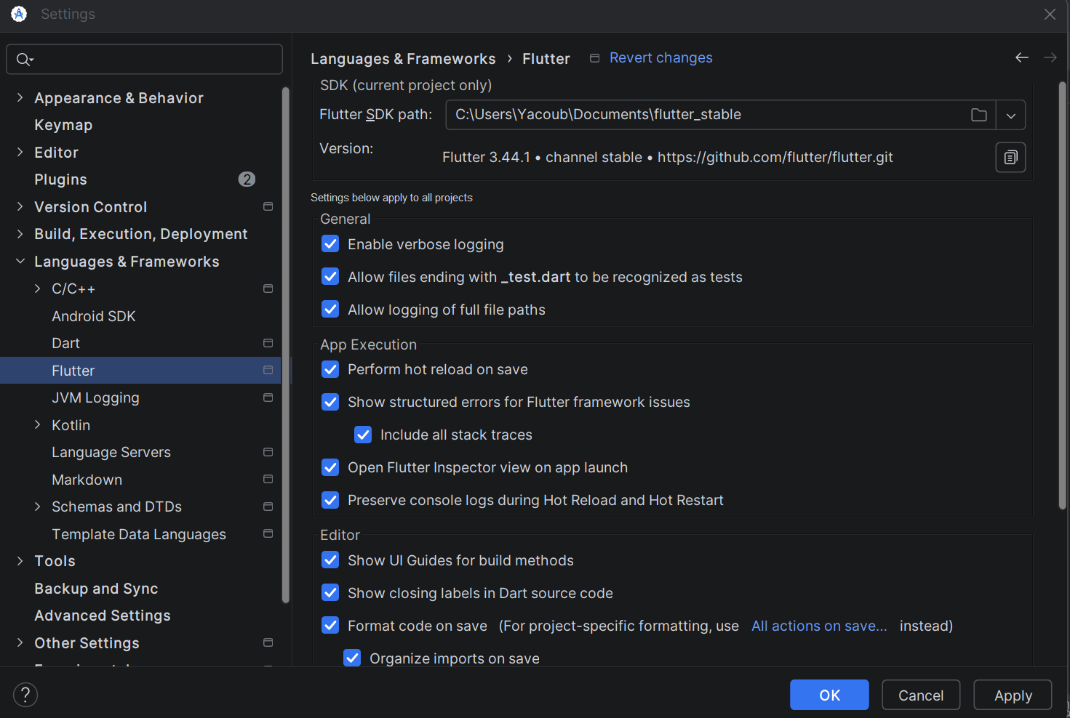

Dart Installation
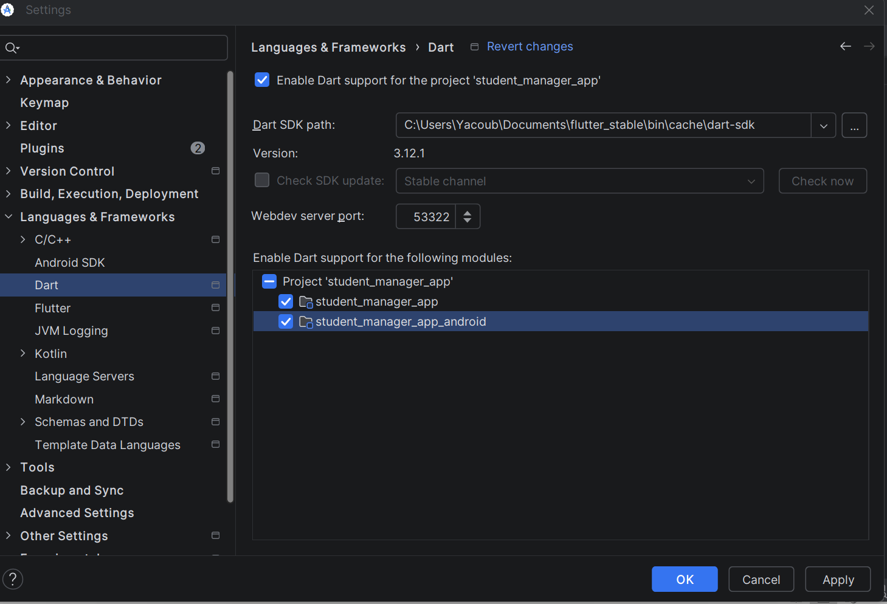

Testing of Flutter workerbility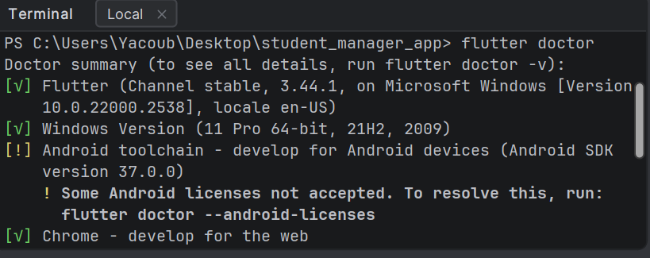

A Simple hello Android Page;

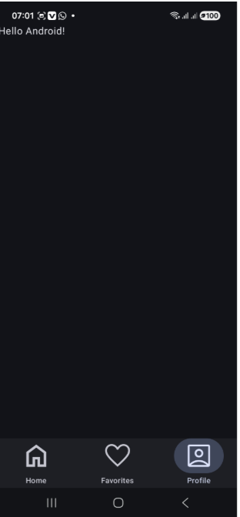

WEEK 2: PROGRAMMING LANGUAGES AND FRAMEWORKS
Student Management App Features:
1. Login Screen with validation
2. Student Registration
3. Add new students
4. View all students
5. Delete students
6. Local storage using SharedPreferences

Code Snippet (Login Screen):
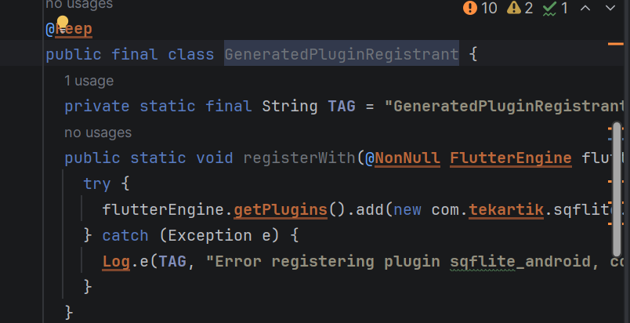

A simple Student management App
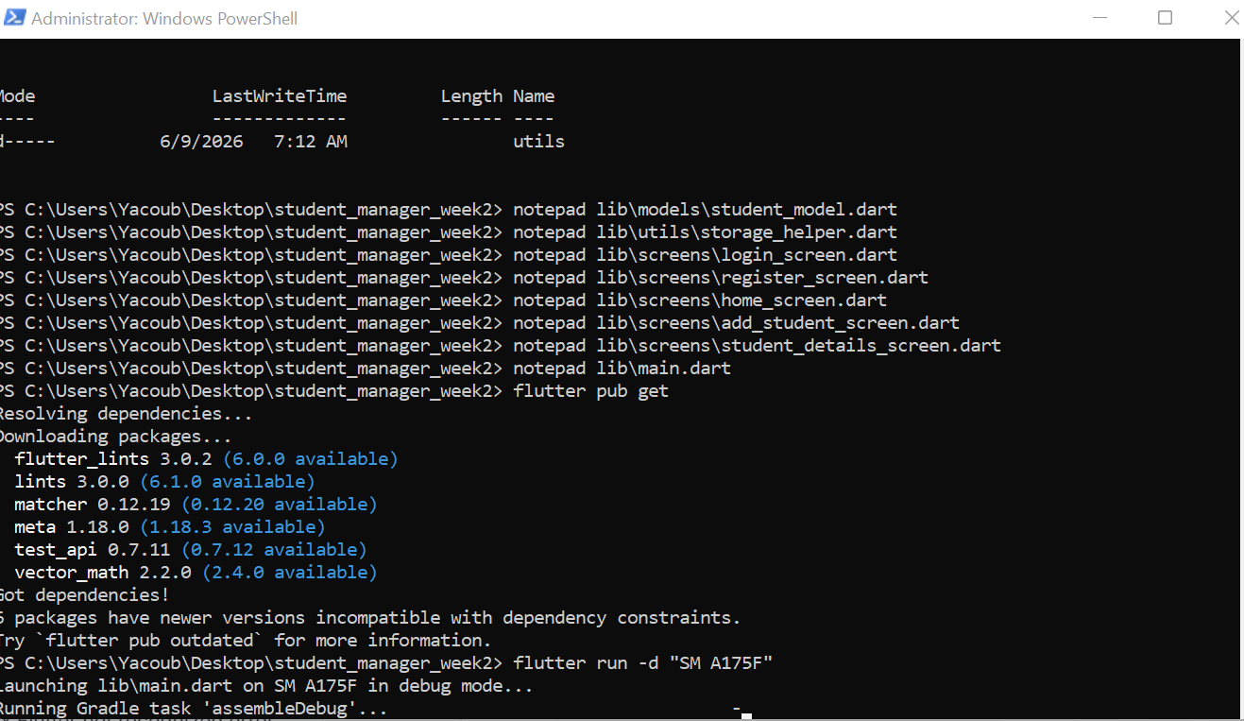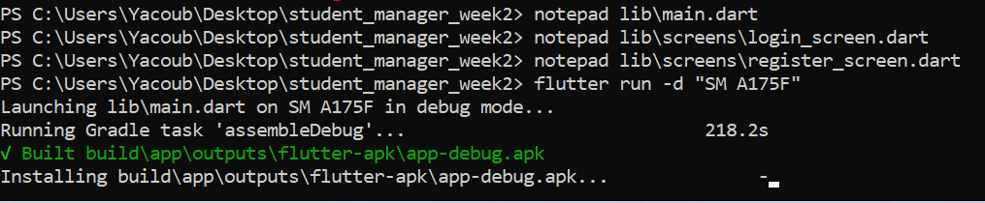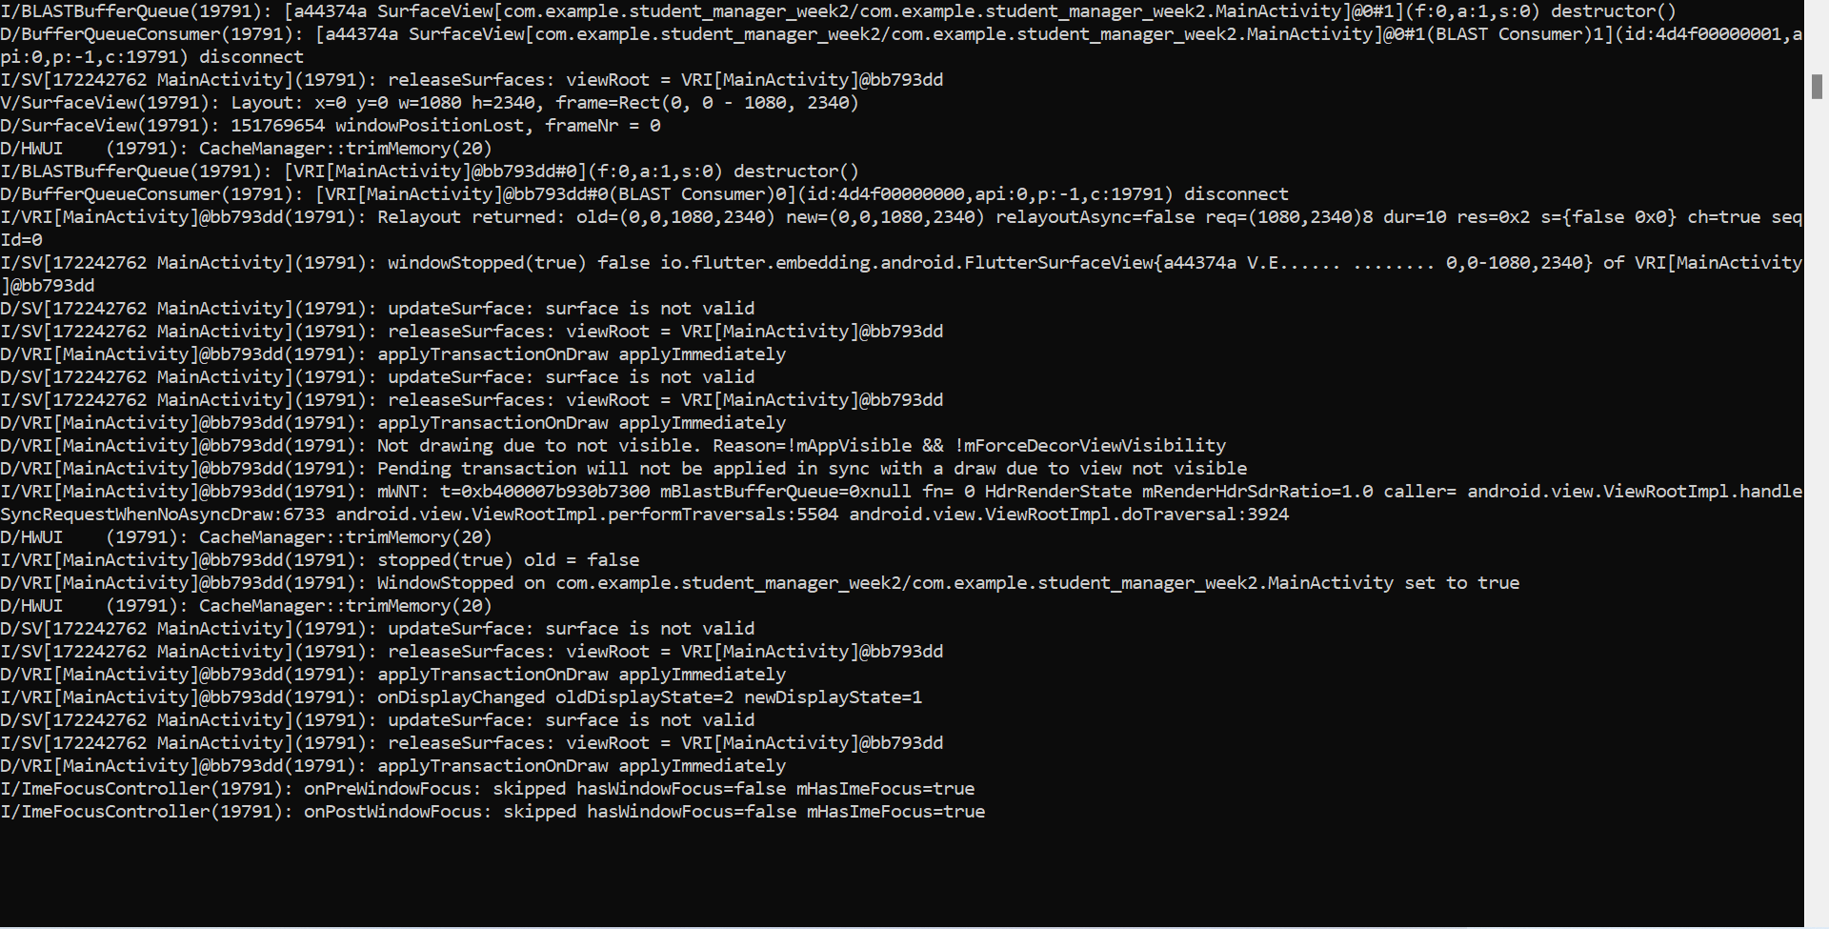
The Student App output (Mobile App screen shots)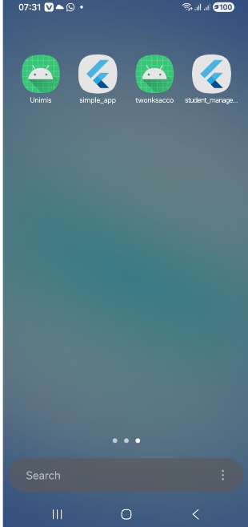 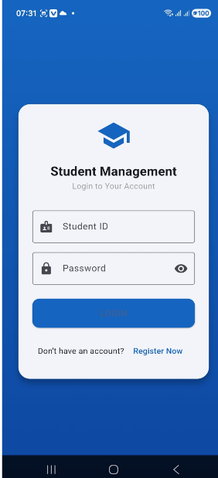 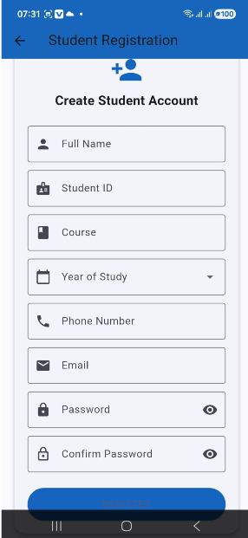 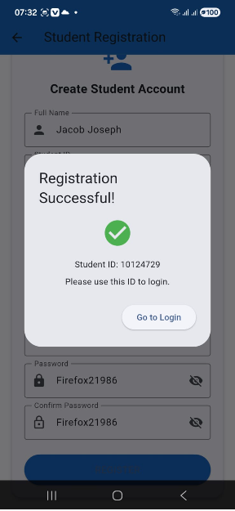 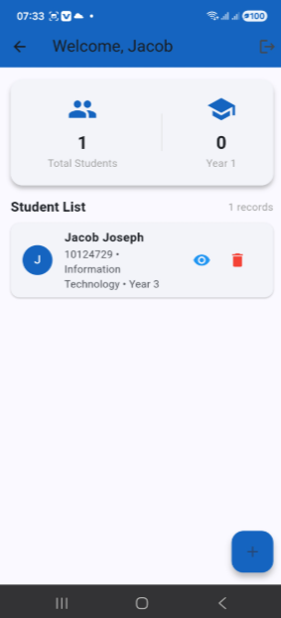 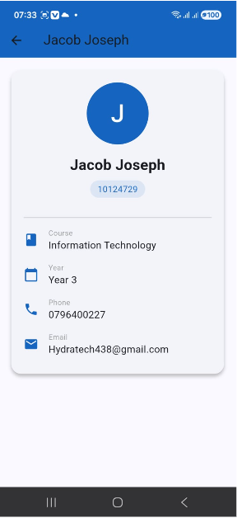 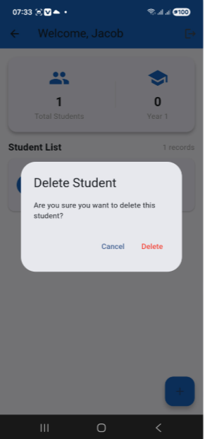

Real world project that I am developing;

2NK Sacco mobile banking app
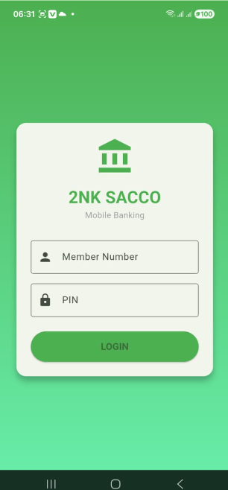
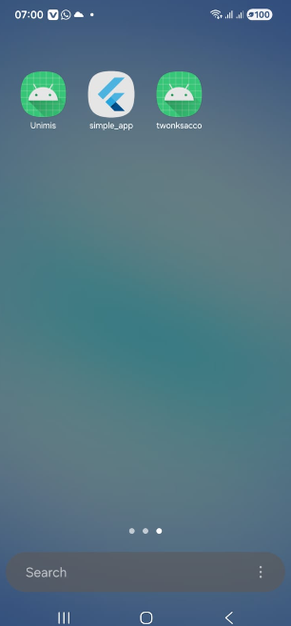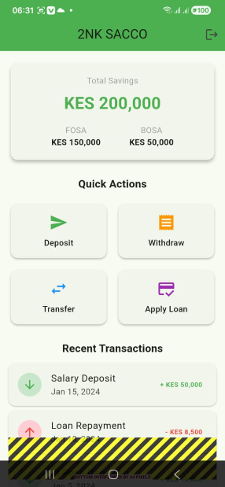

Week 3; link of UI developed by Figma in my github as a link in my README on ;
https://github.com/Jacobjosep/bit4107-Jacob-Joseph-...Assignement-Documentation

Screenshots of the work done on the subsequent weeks
Week 4 to week5
Login page
Admin dashboard
Customer dashboard
And database inteructivity with User interface

Login page
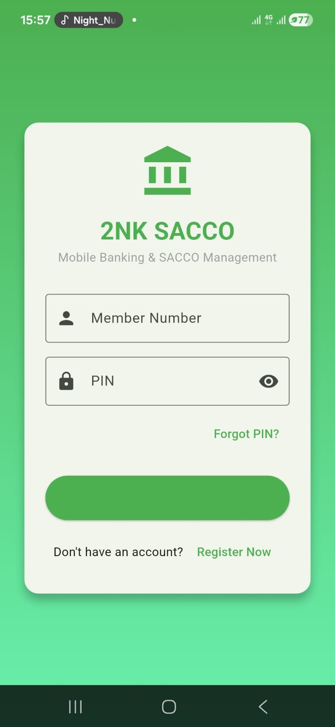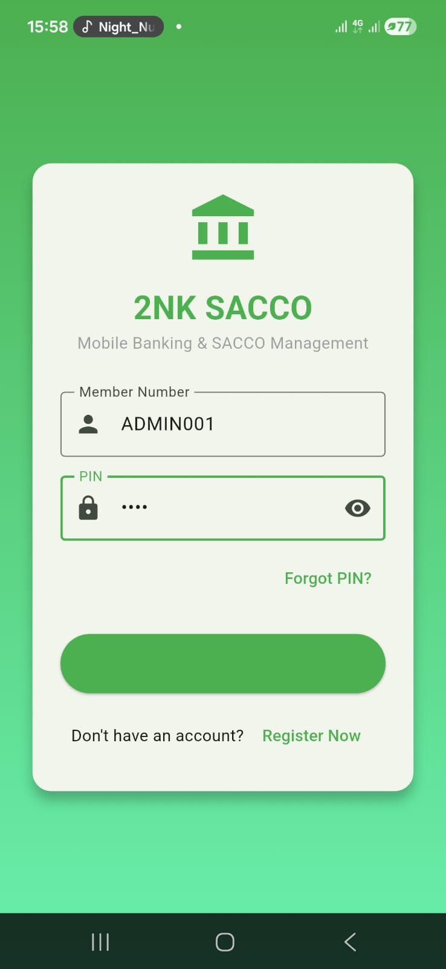ADMIN DASHBOAard
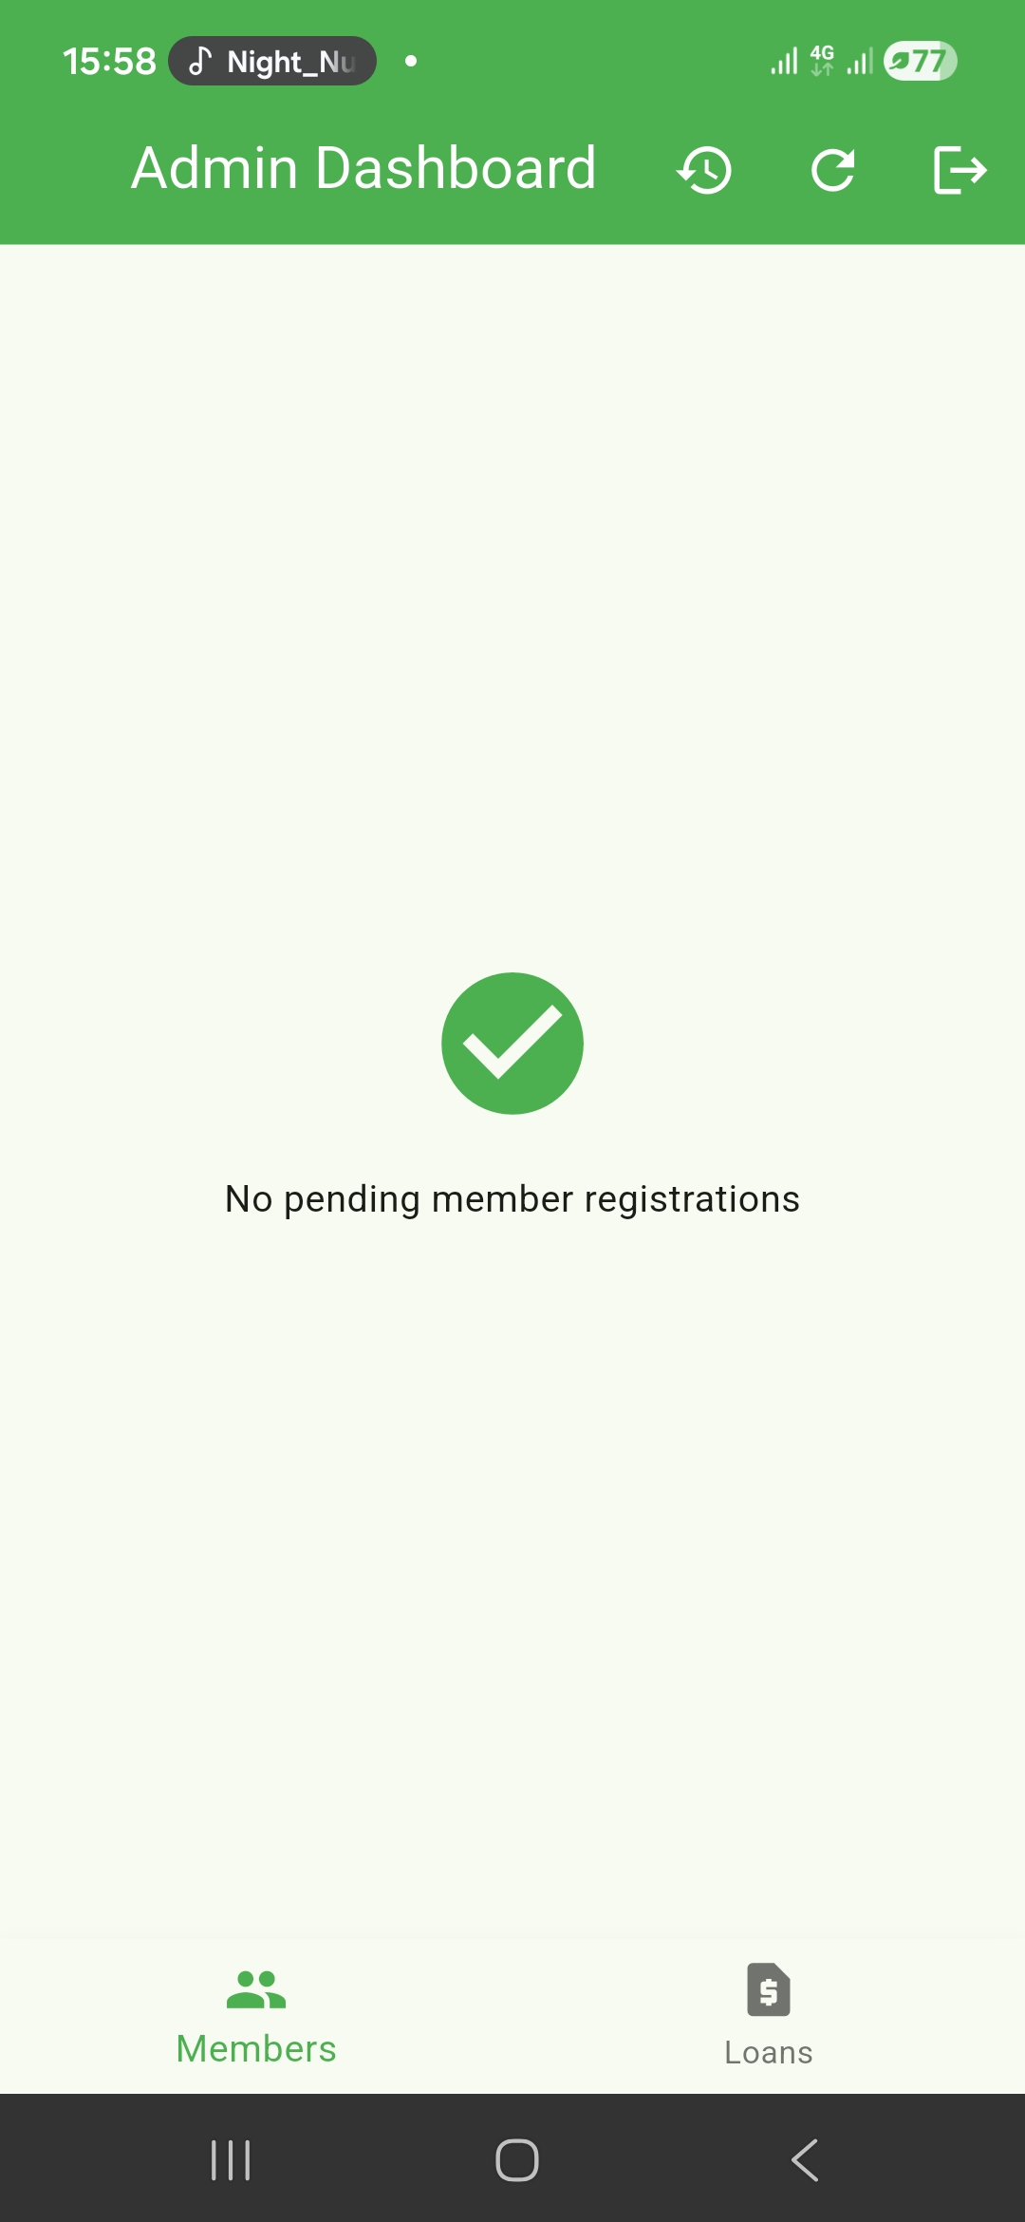ADMIN 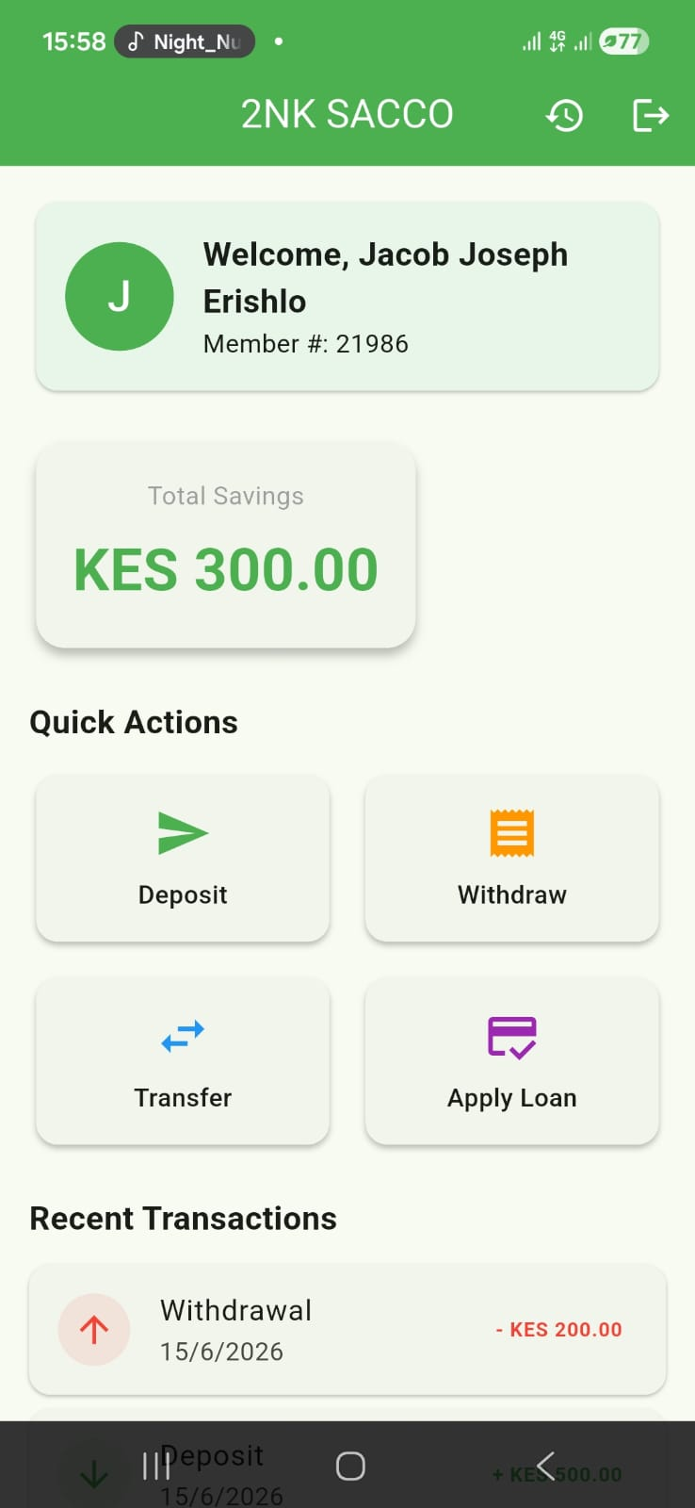customer das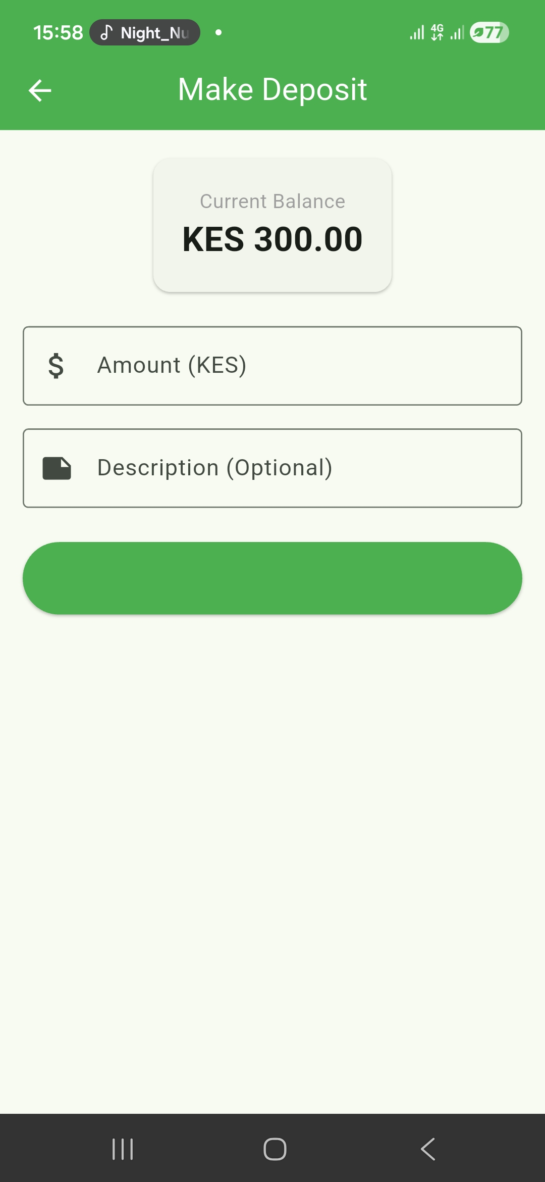

Inteructivity between the customer and admin
